**Practical No:12**

**Company maintains employee information as employee ID, name, designation and salary. Allow user to add, delete information of employee. Display information of particular employee. If employee does not exist an appropriate message is displayed. If it is, then the system displays the employee details. Use index sequential file to maintain the data**

**Pre-requisite:**

* + Knowledge of C++ programming
  + Basic knowledge of files and its operations

**Input:**

Employee Record

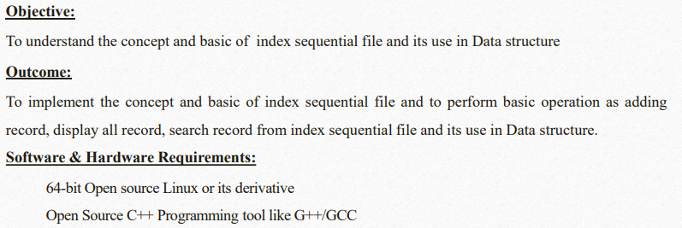

**Description:**

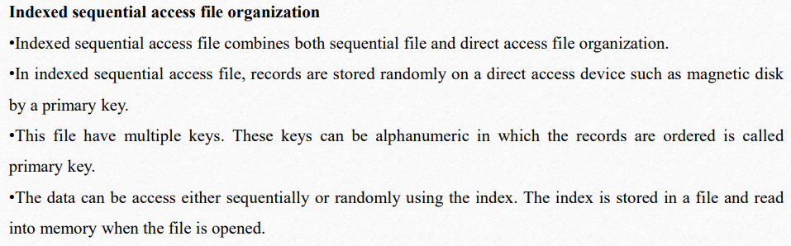

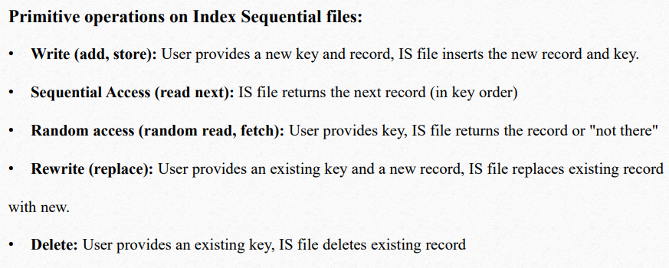

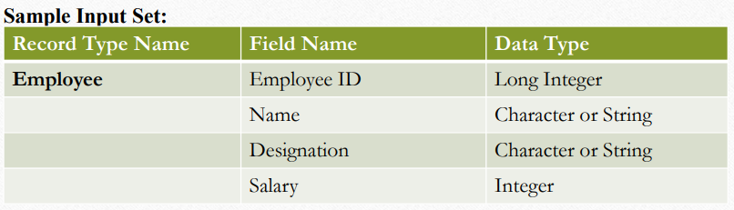

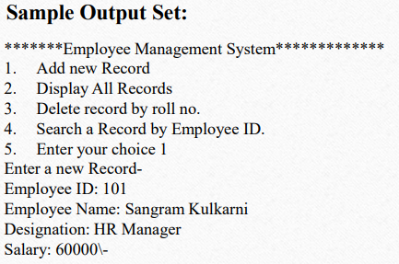

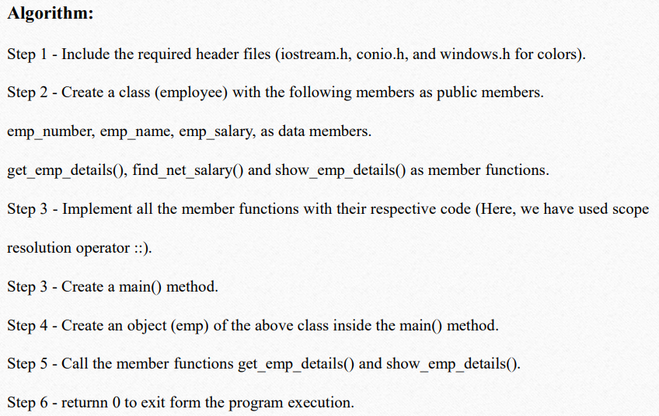

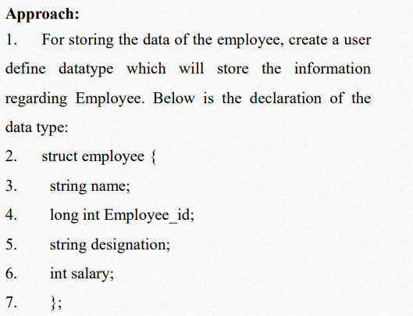

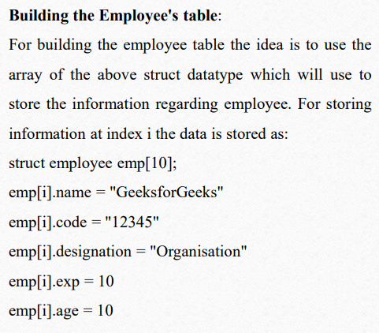

**Deleting in the record:**

Since we are using array to store the data,

therefore, to delete the data at any index shift all the data at that index by 1 and delete the last data of the array by decreasing the size of array by 1.

**Searching in the record:**

For searching in the record based on any parameter, the idea is to traverse the data and if at any index the value parameters matches with the record stored, print all the information of that employee.

**Program:** Write your own program and attach printouts

**Output:**

**Conclusion:**

By this way, we use index sequential file to maintain the data

**Question Bank:**

1. Describe file. What is the need of a file? How the files are stored on external storage? What are the basic operations to be performed on files?
2. Identify the difference between direct access file and index sequential file
3. Identify the difference between direct access file and index sequential file
4. Enlist basic file operations in C